Spring Security
Latest release: 3.2.5.RELEASE
Spring Security can be used to secure any Java application, but it's mostly used for web-based applications.
Glossary
- Authentication: (login!!!)is the process of verifying a principal's identity against what it claims to be.
- Principal: can be user, a device, or a system, but most typically, it's a user. A principal has to provide evidence of identity to be authenticated.
- Credential: is the evidence which is usually a password when the target principal is a user.
- Authorization: (roles!!!) is the process of granting authorities to an authenticated user so that this user is allowed to access particular resources of the target application. The authorization process must be performed after the authentication process. Typically, authorities are granted in terms of roles.
- Access control means controlling access to an application's resources. It entails making a decision on whether a user is allowed to access a resource. This decision is called an access control decision, and it's made by comparing the resource's access attributes with the user's granted authorities or other characteristics.

We can secure applications at the URL access level, the method invocation level, the view-rendering level, and the domain object level.

The Security Filter Chain
(http://docs.spring.io/spring-security/site/docs/3.0.x/reference/security-filter-chain.html)

Spring Security's web infrastructures is based entirely on standard servlet filters. It doesn't use servlets or any other serlvel-based frameworks internally, so it has no strong links to any particular web technology. It deals in HttpServletRequestS and HttpServletResponseS and doesn't care whether the requests come from a browser, a web service client, an HttpInvoker or a AJAX application.

Spring Security maintains a filter chain internally where each of the filters has a particular responsability and filters are added or removed from the configuration depending on which services are required. The ordering of the filters is important as there are dependencies between them.

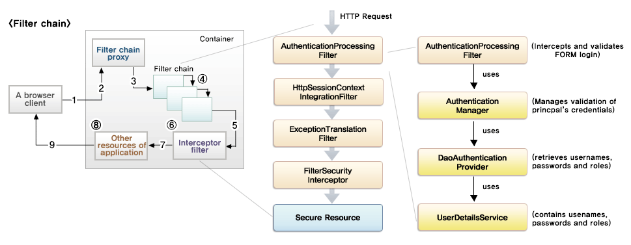

security-context.xml
<security:http>
The <http> element creates a servlet filter, which ensures that the curerntly logged-in user is associated to the appropriate role.

<security:authentication-manager>
The <authentication-manager> element is how Spring Security authenticates the user.

Spring Security Architecture and Design
Main components:
- XML Namespace
- Servlet Filters
- AuthenticationManager
- AuthenticationProvider
- UserDetailsService
- UserDetails
- SecurityContextHolder
- SecurityInterceptor
- AccessDecisionManager
- Authentication
- ConfigAttribute
- ACL
- Taglib

Security Interceptor
One of the most important components of the framework is the Security Interceptor. With the main logic implemented in AbstractSecurityInterceptor and with two concrete implementations in the form of FilterSecurityInterceptor (for web urls) and MethodSecurityInterceptor (for method), the Security Interceptor is in charge of deciding whether a particular petition should be allowed to go through to a secured resource.

The Security Interceptor works with a preprocessing step and a postprocessing step:
- Preprocessing: it looks to see whether the requested resource is secured with some metadata information (or ConfigAttribute). If the requested resource is secured, the Security Interceptor retrieves the Authentication object from the current SecurityContext.
…

for more details see: [2013] Pro Spring Security.pdf pag. 30

Filters and Filter Chain
The filter chain model is what Spring Security uses to secure web application. This model is built on top of the standard servlet filter functionality. Working as an Intercepting Filter Pattern, the filter chain in Spring Security is built on a few single-responsability filters that cover all the different security constraints required by the application.

The filter chain in Spring Security preprocesses and postprocesses all the HTTP requests that are sent to the application and then applies security to URLs that require it.

Authentication Object
The Authentication Object is an abstraction that represents the entity that logs in to the system – most likely, a user.

SecurityContext and SecurityContextHolder
The interface SecurityContext is the place where Spring Security stores the valid Authentication object, associating it with the current thread.
The class SecurityContextHolder is used to access SecurityContext from many parts of the framework.

AuthenticationProvider
AuthenticationProvider is the main entry point for authenticating an Authentication object. This interface has only two methods (authenticate, supports). This is one of the major extension points of the framework. Each of the implementing classes deals with a particular external provider to authenticate against. So if you come across a particular provider that is not supported and need to authenticate against it, you probably need to implement this interface with the required functionality.

AccessDecisionManager
AccessDecisionManager is the class in charge of deciding if a particular Authentication object is allowed or not allowed to access a particular resource. In its main implementations, it delegates to AccessDecisionVoter objects, which basically compares the GratedAuthorities in the Authentication object against the ConfigAttribute required by the resource that is being accessed, deciding whether or not access should be granted. They emit their vote ot allow access or not. The AccessDecisionManager implementations take the output from the voters into consideration and apply a determined strategy on whether or not to grant access. Voters, however, also can abstain from voting.

UserDetailsService and AuthenticationUserDetailsService
The interface UserDetailsService is in charge of loading the user information from the underlying user store (in-memory, database, and so on) when an authentication request arrives in the application.
The interface AuthenticationUserDetailsService is more generic – it allows you to retrieve a UserDetails using an Authentication object instead of a user name String, making it more flexible to implement. Actually, there is an implementation of AuthenticationUserDetailsService (UserDetailsByNameServiceWrapper) that simply delegates to a UserDetailsService extracting the user name from the Authentication object.

UserDetails
The interface org.springframework.security.core.userdetails.UserDetails object is the main abstraction in the
system, and it’s used to represent a full user in the context of Spring Security.
Normally, developers create their own
implementation of this interface to store particular user details they need or want (like email, telephone, address, and
so on). Later, they can access this information, which will be encapsulated in the Authentication object, and they
can be obtained by calling the getPrincipal method on it.

OAuth2
OAuth protocol was born to reduce “headache” and eliminate proprietary authorization api.

OpenID connect is a protocol built on top of OAuth 2.0 to enable using the same identity to log in (authenticate) to multiple applications. Just as OAuth makes authorization easier for developers, OpenID Connect does the same for authentication.

